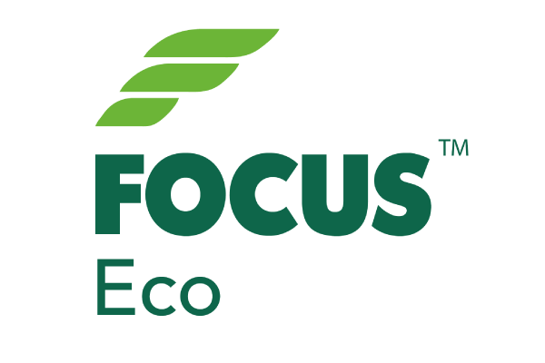
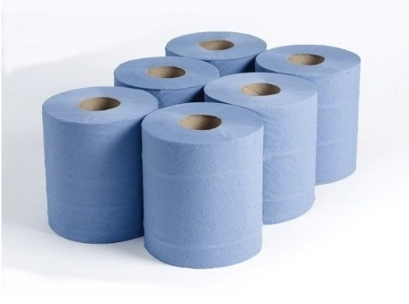

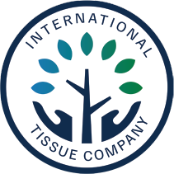
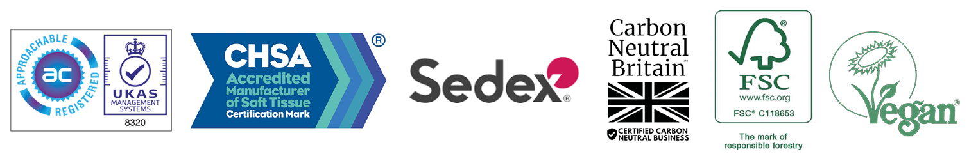

Paper Type | FSC100% Recycled
Colour | Blue
Ply | 2
Roll Length | 150m
Sheet Width | 165mm
Sheet Length | 365mm
Sheets per Roll | 410
Core Diameter | 60mm
Barcode | 7342839834405

Product Data
Pallet Specification
Case Specification
Accreditations
Roll Specification

Focus Eco 2 Ply Blue 150m 165mm Flat Sheet

Product Code | BC150
Date of Issue | 01/06/2023
Commodity Code | 48030090
Country of Origin | UK

Case Quantity | 6
Case Weight | 5.4kg
Case Dimensions (W x L x H) | 340mm x 490mm x165mm
Packaging Materials | LDPE Shrink contains a minimum of 30% PCR
Packaging Disposal | Recycled board core and LDPE wrap can both be widely recycled.

Cases per Layer | 7
Layers by Pallet | 13
Pallet Height | 2.3mm
Cases per Pallet | 91
Double Stacked: | No

