

Nature Mini Jumbo Toilet Roll

Product Code: | JTR152 |  | 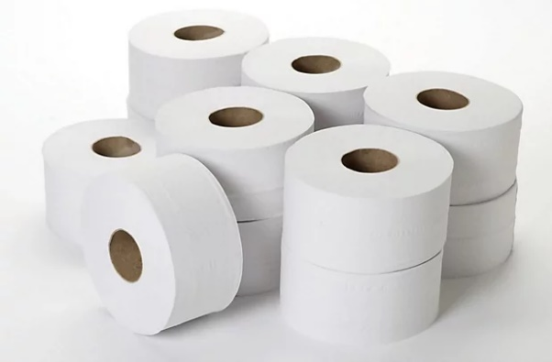
Date of issue: | 01/06/2023
Commodity Code: | 48030090
Country of Origin: | UK

Roll Specification |  |  | Pallet Specification
Paper Type: | FSC Recycled 100% |  | Cases per Layer: | 7
Colour: | White |  | Layer per Pallet: | 12
Ply: | 2 |  | Pallet Height: | 2.3m
Sheet Width: | 86mm |  | Cases per Pallet: | 84
Roll Length: | 150M |  | Double Stacked: | No
Core Diameter: | 60mm
Barcode: | 7342839835112

Case Specification |  |  | Accreditations
Case Quantity: | 12
Case Weight: | 4.9kg |  | 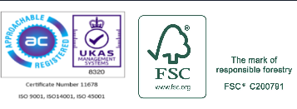  
Case Dimensions (WxLxH): | 345mm x 525mm x170mm
Packaging Material: | LDPE Shrink contains a minimum 30% PCR |  |   
Packaging Disposal: | Recycled board core and LDPE wrap, both can be widely recycled.  

